Carbody Structure and Exterior

Introduction

Use

Purpose

Parts List

All figures are assigned to an individual page unless views are required to show a complete listing of equipment.

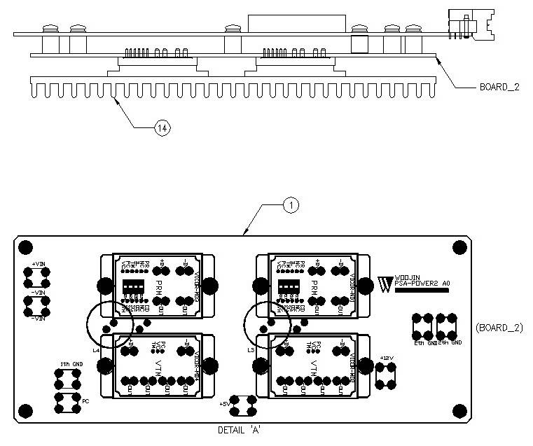

Figure 2.1. PSA Power Board2

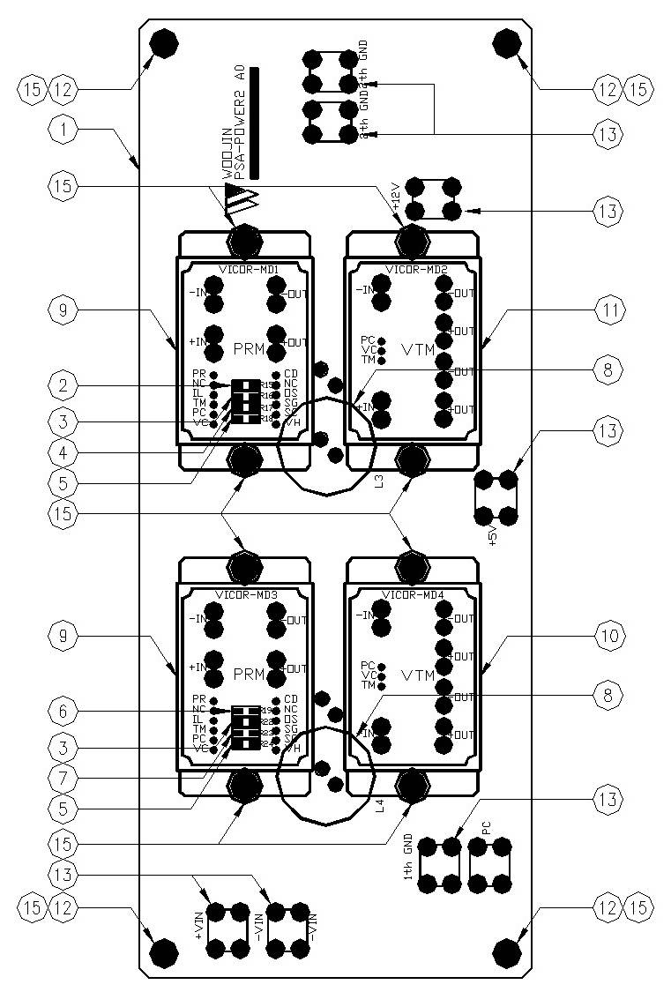

Figure 2.2.1. PSA Power Board2 (Detail A)
Table 1 - Figure 2.1. psa Power board2
FIG No. | PART NUMBERS |  |  | ITEM DESCRIPTION | VENDOR CODE | QTY
 | HRC | VENDOR | DTP
1 |  | PSA-POWER2 A0 |  | . BOARD, | HANSAEM | 1
2 |  | RC2012J390CS |  | . FILM CHIP RESISTOR | SAMSUNG | 1
3 |  | RC2012J202CS |  | . FILM CHIP RESISTOR | SAMSUNG | 2
4 |  | RC2012J361CS |  | . FILM CHIP RESISTOR | SAMSUNG | 1
5 |  | RC2012J000CS |  | . FILM CHIP RESISTOR | SAMSUNG | 2
6 |  | RC2012J330CS |  | . FILM CHIP RESISTOR | SAMSUNG | 1
7 |  | RC2012J821CS |  | . FILM CHIP RESISTOR | SAMSUNG | 1
8 |  | 4uH/10A, Φ20, CH203125 |  | . POWER INDUCTOR | TAESUNG  DAEKWANG | 2
9 |  | PR036A480T012FP |  | . DC/DC CONVERTER | VICOR | 2
10 |  | VT048A060T040FP |  | . DC/DC CONVERTER | VICOR | 1
11 |  | VT048A120T025FP |  | . DC/DC CONVERTER | VICOR | 1
12 |  | SUPPORT-NUT(HEXA) M3X10 |  | . SUPPORT | EGPOWER | 4
13 |  | BR111, M3.5X8 |  | . SUPPORT | BEE RYONG | 7
14 |  | AI, D195 X L80 X H13 |  | . HEAT SINK | EGPOWER | 1
15 |  | ROUND, M3 X L8mm |  | . BOLT |  | 16

